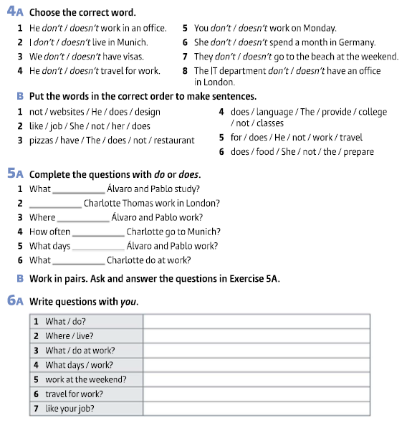

**WRITING**

**8 - Look at the table about Soft Labs. Write a description of the company.**

|  |  |
| --- | --- |
| **Company Name** | Soft Labs |
| **Business** | a web and mobile app development company |
| **Head office** | Los Angeles, USA |
| **Branch offices** | 0 (zero) |
| **Staff** | 50 employees |
| **Activities** | **provide** product strategy, UX/UI design and IoT development services |
| **Some Clients** | World Health Organization, World Wildlife Fund, USC, UCLA |
| **Present Project** | **design** and **develop** a mobile app for a sports stock market |
| **Website** | https://softlabs.com/ |

**Exercise 4A**

1 – doesn´t

2 – don´t

3 – don´t

4 – doesn´t

5 – don´t

6 – doesn´t

7 – don´t

8 – doesn´t

**Exercise 4B**

1 – He does not design websites.

2 – She does not like her job.

3 – The restaurant does not have pizzas.

4 – The college does not provide language lessons.

5 – He doesn not travel for work.

6 – She does not prepare the food.

**Exercise 5A**

1 – do

2 – Does

3 – do

4 – does

5 – do

6 – does

**Exercise 6A**

1. What do you do?
2. Where do you live?
3. What do you do at work?
4. What days do you work?
5. Do you work at the weekend?
6. Do you travel for work?
7. Do you like your job?

**Exercise 8**

Start like this:

*Soft Labs is* a web and mobile app development company. The head office is based in Los Angeles. It doesn´t have branch offices. The company has 50 employees. It provides product strategy, UX/UI design and IoT development services. The clients are World Health Organization, World Wildlife Fund, USC and UCLA. The current / present project is to design and develop a mobile app for a sports stock market. / The company designs and develops a mobile app for a sports stock market. The website is softlabs.com.